**What is WORA?**

1. **Write Once**: Developers write Java code once, typically using a Java compiler to generate bytecode (.class files).
2. **Run Anywhere**: The generated bytecode can be executed on any device or platform that has a Java Virtual Machine (JVM) installed, without needing to recompile the code.

### Key Factors Enabling WORA in Java:

* **Bytecode**: Java code is compiled into platform-independent bytecode rather than machine code. This bytecode can run on any device or platform that supports the Java runtime environment.
* **Java Virtual Machine (JVM)**: The JVM interprets the bytecode and translates it into native machine code at runtime. Each platform has its own JVM implementation, but the bytecode remains consistent across platforms.
* **Platform Independence**: Java’s design focuses on abstraction from platform-specific details, providing libraries and APIs that shield developers from underlying differences between operating systems and hardware architectures.

### Benefits of WORA:

* **Reduced Development Time**: Developers write code once, reducing the effort required to port or maintain code across different platforms.
* **Consistency**: Applications behave consistently across platforms, reducing compatibility issues and improving reliability.
* **Flexibility**: Java applications can run on diverse environments, from desktop computers to mobile devices, embedded systems, and servers.
* **Portability**: Developers can distribute Java applications as bytecode (JAR files), ensuring they can run on any system with a compatible JVM.

### Challenges:

* **Performance**: While JVMs are optimized for performance, bytecode interpretation can introduce overhead compared to natively compiled languages.
* **JVM Dependency**: Applications require a JVM installed on the target platform, which adds a dependency and potential compatibility considerations.

### Real-World Applications:

* **Enterprise Applications**: Java is widely used for building scalable and robust enterprise applications that need to run on various server environments.
* **Mobile Development**: Android apps are primarily developed in Java (or Kotlin), leveraging WORA to target a vast array of Android devices.
* **Web Applications**: Java frameworks like Spring and Java EE enable developers to create web applications that are platform-independent.

### Conclusion:

WORA encapsulates Java’s core philosophy of cross-platform compatibility, making it a popular choice for developers seeking to write software that runs reliably across diverse computing environments. This approach has contributed significantly to Java’s enduring popularity and widespread adoption in both enterprise and consumer software development.

Artifactory: It’s a place where we save the artifact.

JFROG artifactory structure:

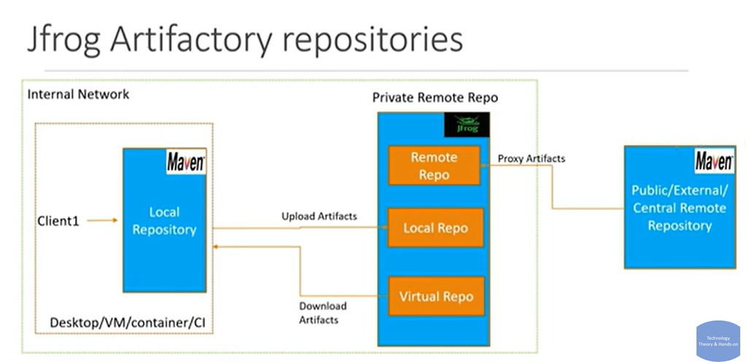

Creating artifactory:

